**Programming an Attiny+Homemade Arduino Shield**

Here, in the 3rd video it has shown how to blink a light using attiny85 and Arduino Uno.Attiny 85 and Arduino wiring is simple .The picture of attiny85 is given below:

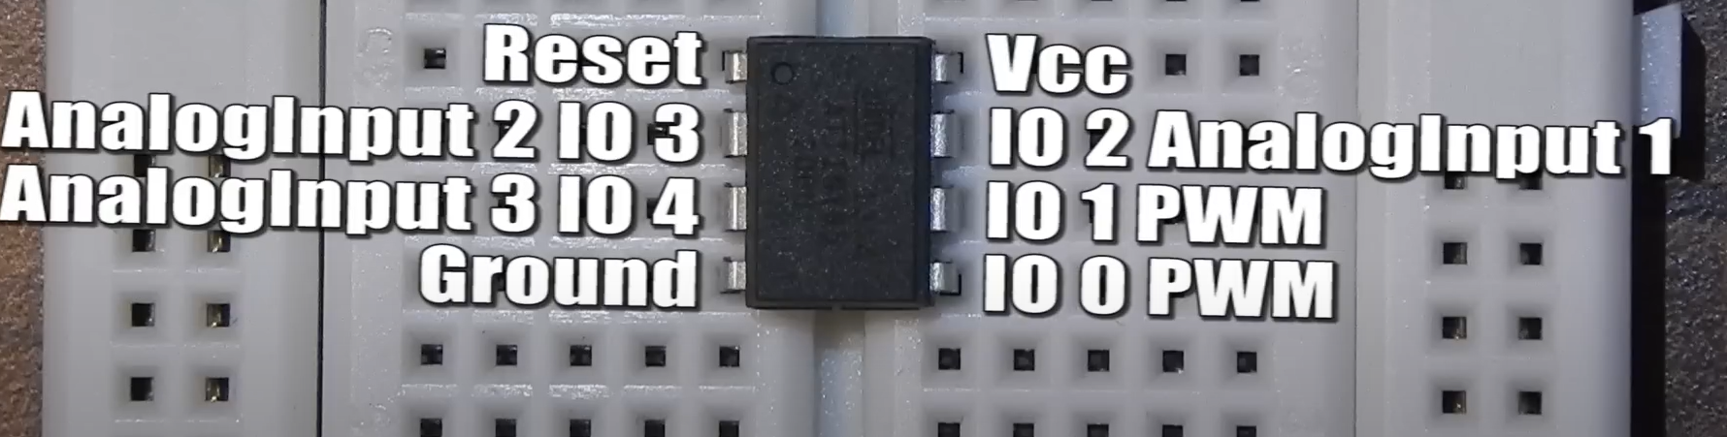

**It is basically a microcontroller . It is a small, low-power 8-bit microcontroller.**

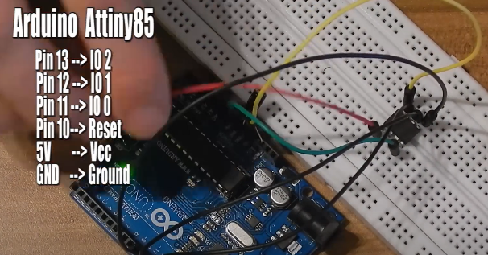**here is the wiring. Make sure that a capacitor is used between the pins of reset and gnd of Arduino .After uploading the code , a light placed in breadboard will blink.**

**USING A PCB CAN HELP ONE TO AVOID THESE COMPLEX WIRING.**